PS5b:
The main purpose of this assignment is to actually make the simulation of the guitar string. This part we are plucking of the string and inserting white noise into every element. We needed to be able to use keys to play sound from each key. To accomplish this task, we needed to first create the guitar string of the given frequency using the sampling rate of 44,100Hz. Then another constructor that takes in a vector of type int_16 (double). Which will initialize the contents of the buffer to the values. The create a function that replaces the items in the buffer with random values between -32768 to 32767. Then a function to delete the sample at the front of the ring buffer and add to the end of the ring buffer the average of the first two samples, multiplied by the energy decay factor.

In this program, I created a pointer to a ring buffer to have sounds plucked in the buffer. I created a member variable to save the sampling rate divided by the given frequency. The first constructor, I enqueued 0 in each element of the amount the user wants for the frequency. In the other constructor, it would be called vectors of type sf::Int16. It would allocated a Ring Buffer of the size given. In the pluck function, I deleted the current Ring Buffer, and relocated a new Ring Buffer. Then I made a loop to insert white noise to each element. In the tic function, I created a 2 variables of type double that save the first value, and return the front of the array. I then added both and divided by 2 to multiply it by the decay. Then finally enqueueing the result value into the ring buffer. Then in the main, I had each key becomes registered and given a sound. To do this, I used the SFML library to use the keyboard function.

The Guitar String assignment helped me understand how to create sound and input them into any key. In the future, maybe creating my own program that can simulate different types of instruments. More understanding of the use of inheritance and the use of calling a function while allocating memory.

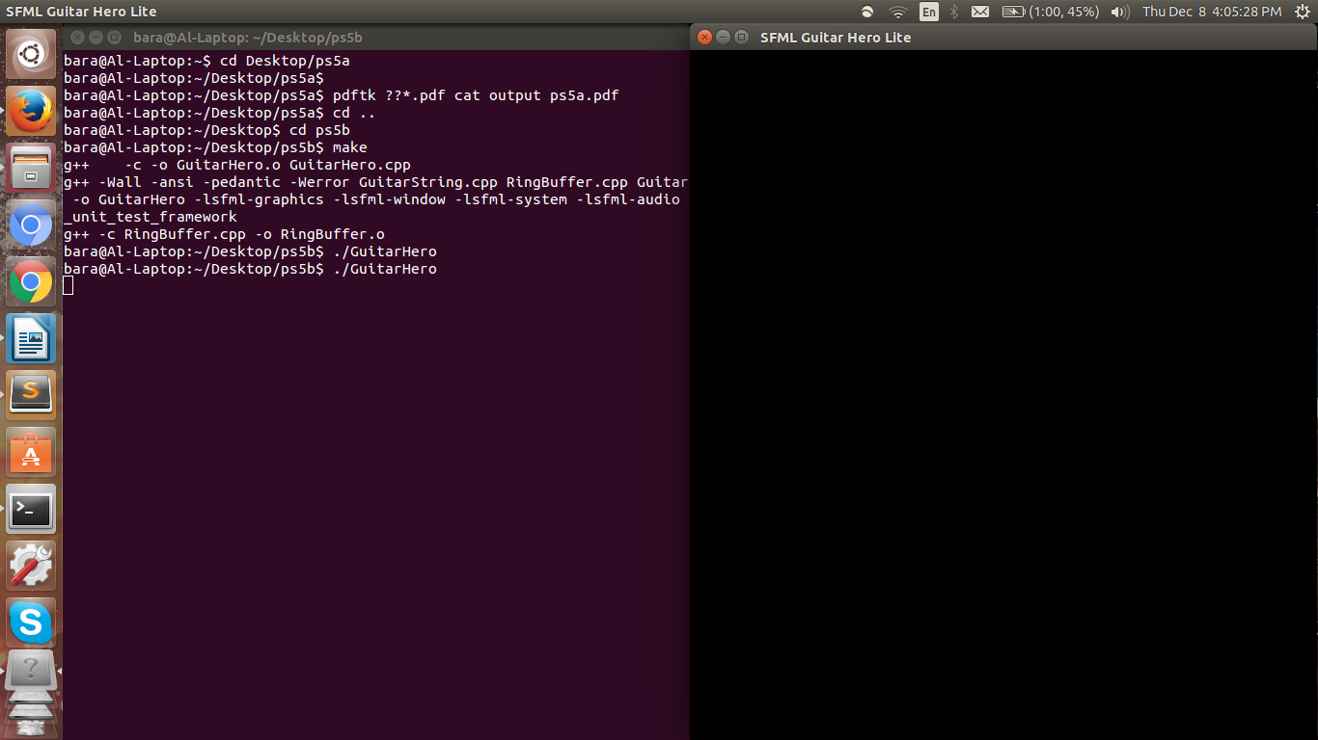
(Compiled with makefile)
(Extra credit for layout was not created)

